Integers Set
# Source: AI Source: Provided by: [Data Path: Persons Table -> ID Column: 1, Name_En Column: Motasem Essam] -> From: [ChatGPT] on [7/15/2026]
The Integers Set is the set of all whole numbers and their negative counterparts, including zero. It extends the Whole Numbers Set by introducing negative numbers, allowing quantities below zero to be represented.
Integers are fundamental to arithmetic, algebra, number theory, geometry, computer science, engineering, physics, economics, and many real-world applications.

Definition
# Source: AI Source: Provided by: [Data Path: Persons Table -> ID Column: 1, Name_En Column: Motasem Essam] -> From: [ChatGPT] on [7/15/2026]
The Integers Set is the collection of all positive whole numbers, negative whole numbers, and zero.
It is denoted by
$$\boxed{Z}$$
The symbol $Z$comes from the German word "Zahlen", meaning numbers.
The set is defined as
$$\boxed{Z=\{…,-3,-2,-1,0,1,2,3,…\}}$$
The ellipsis ($…$) indicates that the set extends infinitely in both the negative and positive directions.

Set Notation
# Source: AI Source: Provided by: [Data Path: Persons Table -> ID Column: 1, Name_En Column: Motasem Essam] -> From: [ChatGPT] on [7/15/2026]
Roster Notation
$$Z=\{…,-3,-2,-1,0,1,2,3,…\}$$
Set-Builder Notation
$$\boxed{Z=\{ x∣x\text{ is a whole number or its negative }\}}$$
or equivalently,
$$\boxed{Z=\{ x∈R∣x\text{ has no fractional part }\}}$$

Examples
# Source: AI Source: Provided by: [Data Path: Persons Table -> ID Column: 1, Name_En Column: Motasem Essam] -> From: [ChatGPT] on [7/15/2026]
Integers include
$$-100, -25, -1, 0, 1, 7, 25, 100$$

Non-Examples
# Source: AI Source: Provided by: [Data Path: Persons Table -> ID Column: 1, Name_En Column: Motasem Essam] -> From: [ChatGPT] on [7/15/2026]
The following are not integers:
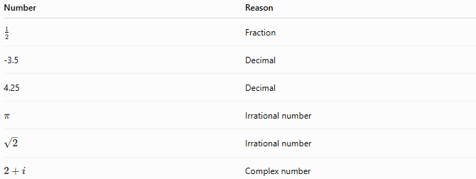
Number | Reason
$$\frac{1}{2}$$ | Fraction
-3.5 | Decimal
4.25 | Decimal
$$π$$ | Irrational number
$$\sqrt{2}$$ | Irrational number
$$2+i$$ | Complex number

Categories of Integers

Negative Integers
# Source: AI Source: Provided by: [Data Path: Persons Table -> ID Column: 1, Name_En Column: Motasem Essam] -> From: [ChatGPT] on [7/15/2026]
$$…,-5,-4,-3,-2,-1$$

Zero
# Source: AI Source: Provided by: [Data Path: Persons Table -> ID Column: 1, Name_En Column: Motasem Essam] -> From: [ChatGPT] on [7/15/2026]
$$0$$
Zero is neither positive nor negative.

Positive Integers
# Source: AI Source: Provided by: [Data Path: Persons Table -> ID Column: 1, Name_En Column: Motasem Essam] -> From: [ChatGPT] on [7/15/2026]
$$1,2,3,4,5,…$$
These are the natural numbers (under the convention that natural numbers start at 1).

Characteristics
# Source: AI Source: Provided by: [Data Path: Persons Table -> ID Column: 1, Name_En Column: Motasem Essam] -> From: [ChatGPT] on [7/15/2026]
Integers are:
- Positive, negative, or zero
- Whole numbers (no fractional part)
- Infinite in both directions
- Ordered
- Discrete (no values between consecutive integers)

Properties
# Source: AI Source: Provided by: [Data Path: Persons Table -> ID Column: 1, Name_En Column: Motasem Essam] -> From: [ChatGPT] on [7/15/2026]
Closure
Integers are closed under:
Addition
$$5+(-8)=-3$$
Subtraction
$$4-7=-3$$
Multiplication
$$(-3)(5)=-15$$
Integers are not closed under:
Division
$$5÷2=2.5$$

Commutative Property
Addition
$$a+b=b+a$$
Multiplication
$$ab=ba$$

Associative Property
Addition
$$\left(a+b)+c=a+(b+c\right)$$
Multiplication
$$\left(ab)c=a(bc\right)$$

Distributive Property
$$a(b+c)=ab+ac$$

Additive Inverse
Every integer has an additive inverse.
Examples:
$$5↔-5 \\ -12↔12 \\ 0↔0$$
The sum of a number and its additive inverse is
$$0.$$

Ordering
Integers are ordered as
$$⋯<-3<-2<-1<0<1<2<3<⋯$$
Numbers farther to the right are greater.

Successor
Every integer has a successor.
If
$$n∈Z,$$
then
$$\boxed{\text{Successor}=n+1}$$

Predecessor
Every integer has a predecessor.
If
$$n∈Z,$$
then
$$\boxed{\text{Predecessor}=n-1}$$

Cardinality
The Integers Set is infinite.
Its cardinality is
$$\boxed{ℵ_{0}}$$
It is a countably infinite set.

Relationship to Other Number Sets
# Source: AI Source: Provided by: [Data Path: Persons Table -> ID Column: 1, Name_En Column: Motasem Essam] -> From: [ChatGPT] on [7/15/2026]
$$\boxed{N⊂W⊂Z⊂Q⊂R⊂C}$$
Every integer is also:
- a rational number,
- a real number,
- and a complex number (with imaginary part equal to zero).

Examples
# Source: AI Source: Provided by: [Data Path: Persons Table -> ID Column: 1, Name_En Column: Motasem Essam] -> From: [ChatGPT] on [7/15/2026]
Example 1
Determine whether
$$-45$$
is an integer.
Yes.
$$-45∈Z$$

Example 2
Determine whether
$$0$$
is an integer.
Yes.
$$0∈Z$$

Example 3
Determine whether
$$7$$
is an integer.
Yes.
$$7∈Z$$

Example 4
Determine whether
$$\frac{3}{4}$$
is an integer.
No.
Fractions are not integers.

Example 5
Determine whether
$$-2.8$$
is an integer.
No.
Decimals are not integers.

Applications
# Source: AI Source: Provided by: [Data Path: Persons Table -> ID Column: 1, Name_En Column: Motasem Essam] -> From: [ChatGPT] on [7/15/2026]
Integers are used in:
- Arithmetic
- Algebra
- Number Theory
- Geometry
- Computer Science
- Engineering
- Physics
- Economics
- Statistics
- Programming

Real-Life Applications
# Source: AI Source: Provided by: [Data Path: Persons Table -> ID Column: 1, Name_En Column: Motasem Essam] -> From: [ChatGPT] on [7/15/2026]
Integers are used for:
- Temperatures above and below zero
- Elevation above and below sea level
- Financial gains and losses
- Building floor numbers
- Bank account balances
- Coordinates on a number line
- Sports scores
- Inventory adjustments
- Electrical charge
- Profit and loss calculations

Common Mistakes
# Source: AI Source: Provided by: [Data Path: Persons Table -> ID Column: 1, Name_En Column: Motasem Essam] -> From: [ChatGPT] on [7/15/2026]
- Confusing integers with whole numbers.
- Assuming fractions are integers.
- Forgetting that 0 is an integer.
- Thinking every rational number is an integer.
- Confusing negative integers with negative rational numbers.

Key Points
# Source: AI Source: Provided by: [Data Path: Persons Table -> ID Column: 1, Name_En Column: Motasem Essam] -> From: [ChatGPT] on [7/15/2026]
- Integers include negative numbers, zero, and positive numbers.
- They contain no fractions or decimals.
- They are infinite in both directions.
- They are closed under addition, subtraction, and multiplication.
- They extend the Whole Numbers Set by including negative numbers.

Integers vs. Whole Numbers
# Source: AI Source: Provided by: [Data Path: Persons Table -> ID Column: 1, Name_En Column: Motasem Essam] -> From: [ChatGPT] on [7/15/2026]
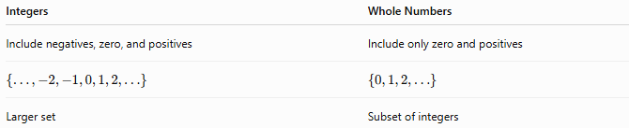
Integers | Whole Numbers
Include negatives, zero, and positives | Include only zero and positives
$$\left\{…,-2,-1,0,1,2,…\right\}$$ | $$\left\{0,1,2,…\right\}$$
Larger set | Subset of integers

Integers vs. Rational Numbers
# Source: AI Source: Provided by: [Data Path: Persons Table -> ID Column: 1, Name_En Column: Motasem Essam] -> From: [ChatGPT] on [7/15/2026]
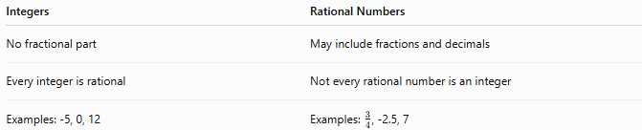
Integers | Rational Numbers
No fractional part | May include fractions and decimals
Every integer is rational | Not every rational number is an integer
Examples: -5, 0, 12 | Examples: $\frac{3}{4}$, -2.5, 7

Integers vs. Natural Numbers
# Source: AI Source: Provided by: [Data Path: Persons Table -> ID Column: 1, Name_En Column: Motasem Essam] -> From: [ChatGPT] on [7/15/2026]
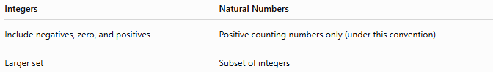
Integers | Natural Numbers
Include negatives, zero, and positives | Positive counting numbers only (under this convention)
Larger set | Subset of integers

Conclusion
# Source: AI Source: Provided by: [Data Path: Persons Table -> ID Column: 1, Name_En Column: Motasem Essam] -> From: [ChatGPT] on [7/15/2026]
The Integers Set, denoted by $Z$, is the set of all negative whole numbers, zero, and positive whole numbers
$$Z=\{…,-3,-2,-1,0,1,2,3,…\}.$$
Integers extend the Whole Numbers Set by introducing negative values, allowing quantities below zero to be represented. They are infinite, ordered, discrete, and closed under addition, subtraction, and multiplication, making them one of the most important number sets in mathematics and a foundation for algebra, number theory, and many real-world applications.

